**AIM-** Introduction to SQL

What is SQL ?

SQL (Structured Query Language) is a standard interactive and programming language for getting information from and updating a [database](http://searchsqlserver.techtarget.com/definition/database). Although SQL is both an [ANSI](http://searchdatacenter.techtarget.com/definition/ANSI) and an [ISO](http://searchdatacenter.techtarget.com/definition/ISO) standard, many database products support SQL with proprietary extensions to the standard language. Queries take the form of a command language that lets you select, insert, update, find out the location of data, and so forth. There is also a programming interfaceDifference between DDL commands and DML commands?

DDL commands – DDL stands for data defining language. The DDL section is used for creating database objects, such as tables. In practice, people often use a GUI for creating tables and so on, so it is less common to hand-write DDL statements than it used to be.DML commands – DML stands for data manipulation language. The DML section is used to manipulate the data such as querying it. While is also common to use a query builder to create queries, people do still hand-craft DML statements, such as queries.

**COMMANDS IN DDL & DML**

**DDL Commands**

* 1. **CREATE:**

**Definition:** It is used to create table.

**Syntax:** CREATE table <tablename>(columnname1 datatype(length),columnname2 datatype(length));

**Statement:** CREATE table student(RollNo number(5),name varchar(30),emailid varchar(20),mobno number(10),dob varchar(10),address varchar(20));

**Output:**

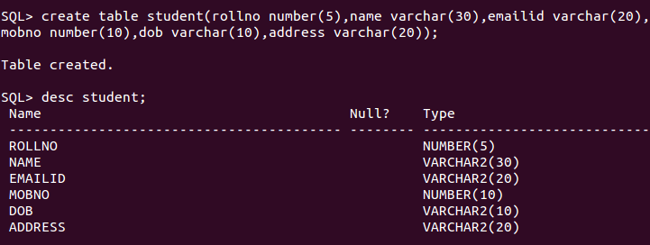

**2. ALTER:**

**Definition:** It is used to add, modify, and drop column in an existing table.

* ADD: It is used to add column or constraint to an existing table.

Syntax: ALTER TABLE <tablename> ADD columnname datatype(length);

Statement: ALTER TABLE student ADD class number(6);

Output:

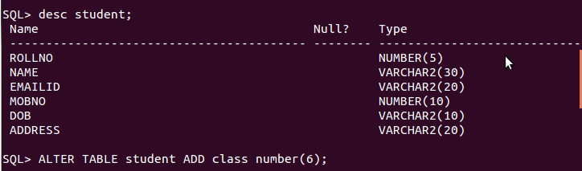

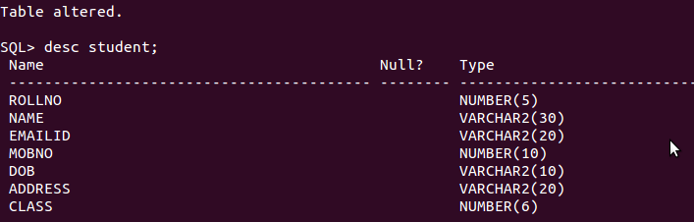

* MODIFY: It is used to modify the length 5 to 25 of Name attribute.

Syntax: ALTER table <tablename> MODIFY columnname datatype(length);

Statement: ALTER table student MODIFY class varchar(6);

Output:

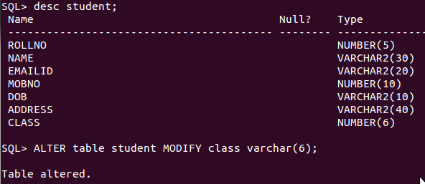

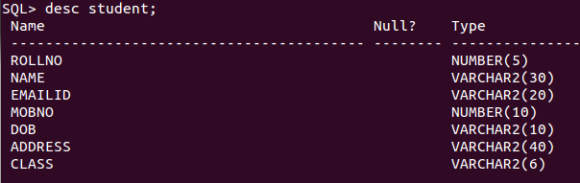

1. DROP:

Definition: It is used to drop the entire structure.

Syntax: ALTER table <tablename> DROP column columnname;

Statement: ALTER table student DROP column class;

Output:

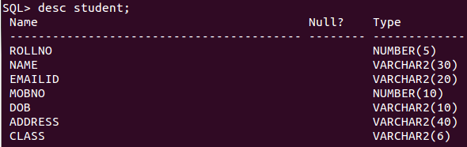

C:\Users\Pulkit Garg\AppData\Local\Microsoft\Windows\INetCacheContent.Word\p5 - Copy (2).png

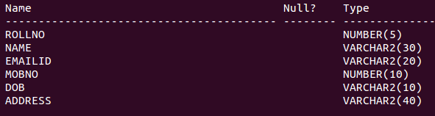

**DML Commands:**

1. INSERT:

Definition: It is used to insert a new row in a table:

Syntax: INSERT into <tablename> value(column1,column2);

Statement: INSERT into student values(45,'daksha garg','dakshag27@gmail.com',9910636004,'27.12.1996','b-208 patel nagar 2');

Output:

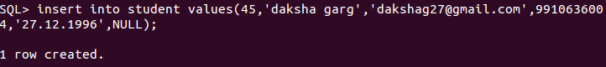

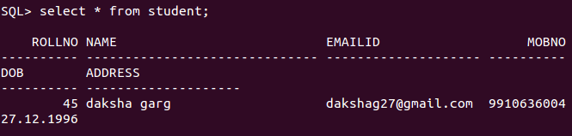

2. UPDATE:

Definition: It is used to updates existing data within a table

Syntax: UPDATE tablename SET columnname = New Value where Columnname = old value;

Statement: UPDATE emp SET Name = 'xyz' where Name 'Daksha';

OUTPUT:

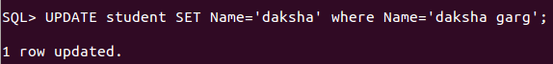

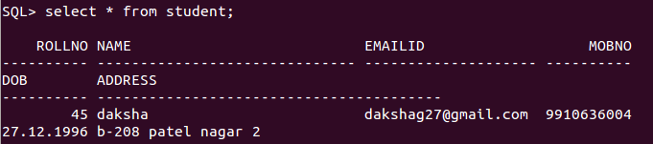

3.DELETE:

Definition: used to delete complete tuple(row).

Syntax: DELETE from <tablename> where columnname = value;

Statement: DELETE from student where name= ‘chitranshi’;

Output: 